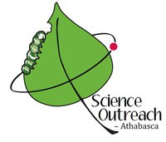
25th Anniversary Celebration of Science Outreach – Athabasca

The members of Science Outreach – Athabasca hereby invite anyone who wishes to attend a potluck supper to celebrate our 25 years of promoting science and technology to the public. There will be a looping slide show of samples of our activities but no speeches. If conditions are suitable, we will be mostly outside, on a deck, enjoying spring weather. If not, we will be inside despising spring weather.
Date: Tuesday 12 May 2026
Location: Baptiste Lake (20 minutes West of Athabasca; map available for finding Robert Holmberg’s home)
Arrival: any time after 4 PM
Supper: 6:00 PM (please bring something to share)
Departure: before dawn

